A robot is located at the top-left corner of a *m* x *n* grid (marked 'Start' in the diagram below).

The robot can only move either down or right at any point in time. The robot is trying to reach the bottom-right corner of the grid (marked 'Finish' in the diagram below).

How many possible unique paths are there?

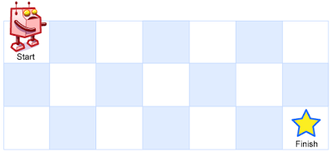

动态规划的思想。用一个二维数组保存从0行0列开始的路径数。当只有一行或一列时只有一条路径，否则有t[i-1][j] + t[i][j-1]条路径。